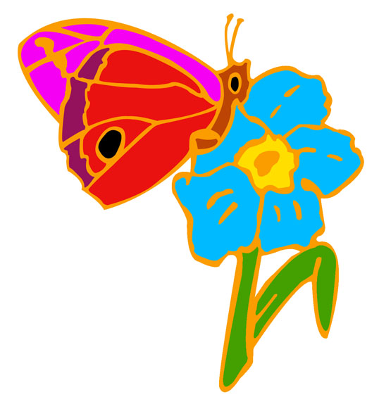

The following books can all be purchased from Amazon - if you use the link to Amazon on the everyclick.com website below it helps raise money for The Donor Family Network. http://www.everyclick.com/uk/donorfamilynetwork
For Children

Muddles, Puddles and Sunshine
Diana Crossley

Water bugs and dragonflies
Doris Stickney

Sad Isn't Bad
Michaelene Mundy

When something terrible happens children can learn to cope with grief
Marge Heegaard

When someone very special dies
Marge Heegaard

Help Me Say Goodbye
Janis Silverman

When Dinosaurs Die
Laurie Krasny Brown and Marc Brown

I Miss You
Pat Thomas

Always and Forever
Alan Durant

Goodbye Mog
Judith Kerr

When Goodbye is Forever
Lois Rock

Remembering my Brother
Ginny Perkins

Remembering Mum
Ginny Perkins

Help Me Say Goodbye
Janis Silverman

I’ll Always Love You
Hans Wilhelm

For Older Children/Teenagers

What on Earth do you do when someone dies?
Trevor Romain

Finding a Way Through When Someone Close Has Died
Pat Mood and Lesley Whittaker

For adults

A Grief Observed
C S Lewis

Death and how to survive it
Kate Boydell

You’ll Get Over It – The Rage of Bereavement
Virginia Ironside

Sad Book
Michael Rosen and Quentin Blake

I’m Grieving As Fast As I Can
Linda Feinberg

